Experiment 08:
Name of the Experiment: Voltage Divider Biasing of Enhancement Type MOSFET

Theory:

MOSFETs
A Metal–Oxide–Semiconductor Field Effect Transistor (MOSFET) is a type of Field Effect Transistor (FET) that operates with voltage control at the gate terminal. Unlike BJTs, which are current-controlled devices, MOSFETs use an electric field induced by the gate-to-source voltage ($V_{GS}$) to control the current flowing from drain to source ($I_{D}$). The MOSFET has three terminals: Gate (G), Drain (D), and Source (S). In an n-channel Enhancement-type MOSFET (E-MOSFET), no drain current flows when V. Conduction begins only when. Above this threshold, the drain current follows the quadratic relationship:

$$I_{D}=k{\left(V_{GS}-V_{th}\right)}^{2}$$Here,
$I_{D}$ is the drain current.
The $V_{GS}$ is the Gate to Source Voltage.
The $V_{th}$ is the threshold voltage at which the MOSFET turns on
$k$ is the transconductance parameter which solely depends on the type MOSFET being used.

Biasing Techniques
To set a proper operating point (Q-point) for MOSFET circuits, several biasing techniques can be used.
The Self Biased Arrangement (Feedback biasing arrangement): This circuit, designed in figure 7.1, shows how the self-biased circuit works. The idea is to connect a very high resistance between the drain and gate which can draw huge of voltage and supply it to the gate terminal. Since the current $I_{G}=0 A$, the current in flowing through $R_{D}$ remains the same.
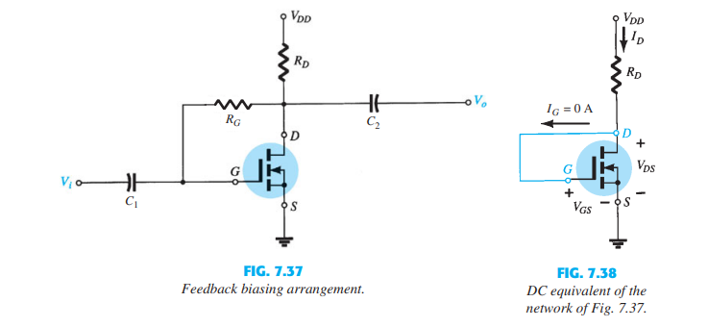
Fig 7.1:
Feedback Biasing Arrangement
Fig 7.2:
DC equivalent of Fig 7.1
Fig 7.2
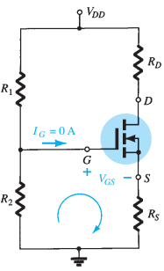
Voltage Divider Biasing Circuit: The circuit given in Figure 7.3, shows how the voltage divider circuit works. What this circuit does is that since $I_{G}=0 A$, it takes the voltage $V_{DD}$ and divides it amongst $R_{1}$ and $R_{2}$, thus, using Voltage Divider Rule, the gate voltage $\left(V_{G}\right)$ applied will be equal to the voltage across $R_{2}$.
$$V_{G}=\frac{R_{2}}{R_{1}+R_{2}}V_{DD}$$
Using KVL in the given loop in Figure 7.3, we can get the following equation:
$$V_{GS}=V_{G}-I_{D}R_{S}$$Recall that drain current $\left(I_{D}\right)$ flowing through $R_{D}$ and $R_{S}$ are the same.

Fig 7.3:
Voltage Divider Biasing Arrangement

Transfer Curve
The Transfer Curve for an n-type MOSFET can be found using Shockley’s equation, the graph in Figure 7.4 shows a sudden exponential increase of drain current when the gate-to-source voltage applied is greater than the threshold voltage $\left(V_{GS}>V_{th}\right)$.
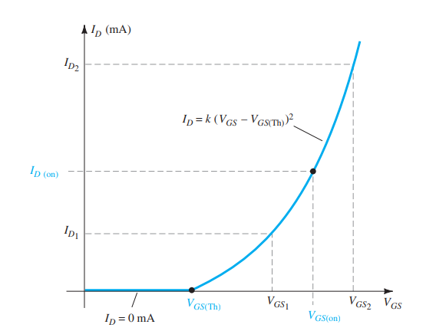
Fig 7.4:
Transfer Curve for n-channel Enhancement type MOSFET

This curve is obtained after knowing the parameter $k$, which can be found using the equation:
$$k=\frac{I_{D(on)}}{{\left(V_{GS\left(on\right)}-V_{th}\right)}^{2}}$$The drain current and gate voltages needed to calculate $k$, are taken from the data sheet of the MOSFET being used.

Q-Point
The Q-point (short for Quiescent Point) is the operating point of a transistor when no input signal is applied. For this lab, it represents the steady-state values of drain current $\left(I_{D}\right)$ and gate-to-source voltage $(V_{GS})$ that are set by the biasing network.
Which means, after building the biasing circuit in the lab, your measurements will be your Q-point values. However, it is also important to find the theoretical Q-point of a MOSFET from the transfer curve by applying load line analysis as shown in Figure 7.5.
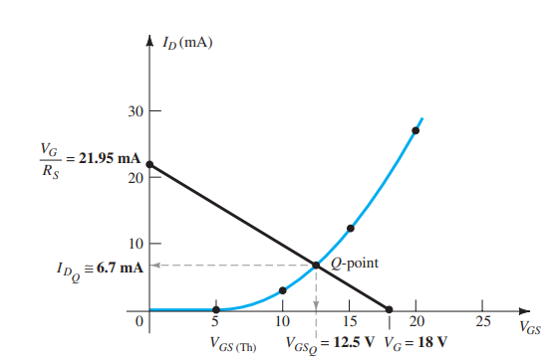
$$\frac{V_{G}}{R_{S}}$$

Fig 7.5:
Load Line Analysis on the Transfer Curve for n-channel Enhancement type MOSFET

Equipment and Component:

Serial no. | Component Details | Specifications | Quantity
1 | MOSFET | IRF540 | 1 piece
2 | Resistor | 1kΩ, 470Ω, 5kΩ | 1 piece each
3 | Potentiometer (POT) | 10kΩ | 1 piece
4 | Trainer Board |  | 1 unit
5 | DC Power Supply |  | 1 unit
6 | Digital Multimeter |  | 1 unit
7 | Chords and Wires |  | 1 unit

Experimental Setup 1:

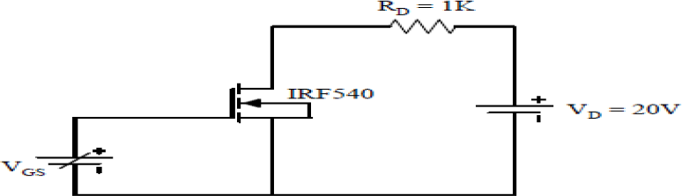

Procedure:
- Build the circuit as per the setup.
- Set VGS to zero and VDS = 15V measure ID.
- Increase the gate voltage VGS gradually and record the readings.
- Take reading until ID suddenly increases and goes to 15 mA.
- Note the value of VGS, and ID (approximately 15 mA) and write it down in Table 7.1.
- Calculate the value of k.

Table 7.1: Calculation to find $k$

$$V_{GS(on)}$$ | $$I_{D\left(on\right)}$$ | $$V_{th}$$ | $$k=\frac{I_{D(on)}}{{\left(V_{GS\left(on\right)}-V_{th}\right)}^{2}}$$
 | 10 mA | 3 V

Experimental Setup 2:
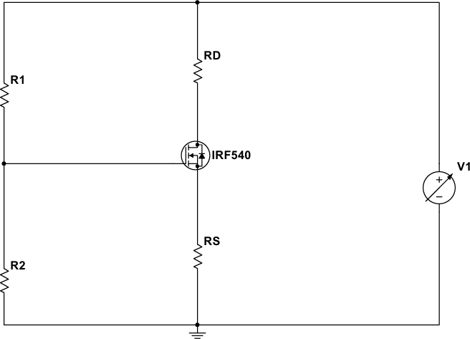
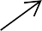

Procedure:
- Connect Resistors R1 = 5kΩ, RD=1kΩ, RS=470Ω and set up the circuit as shown.
- For R2, connect a 10kΩ potentiometer and set it to minimum, and set V1=18V.
- Measure VG by putting one probe of the DMM to Gate terminal and the other probe to ground.
- Gradually Increase R2 until VG = 8V.
- Note the value of VGS, and ID and write it down in the table.

Table 7.2: Finding the Q-points

Measured |  | Calculated
$$VGSq$$ | $$IDq$$ | $$VGSq$$ | $$IDq$$

Report:
- Draw the transfer curve based on the data that you have calculated in Table 1.
- Find the Q-points from your graph and check whether your Measured data matches with the data you found.
- Does the Shockley equation depend on the type of biasing circuit used or the type of MOSFET being used? Explain.

